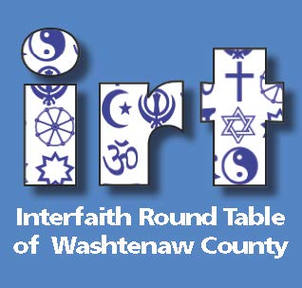
2018
FACES OF FAITH
Sunday, January 14, 4-6 pm
(along with other national Religious Freedom Day observances)
Come hear the stories of local clergy & other designated religious
leaders from 6 traditions. This year each will speak to the whole
group and follow-up conversations will be probing and engaging.
A separate session will be held for students up through H.S.
Muslim Jewish Christian
Imam Mufti Abdullah Al-Mahmudi Abby Wells Kelly Dunlop
Muslim Community Association Temple Echad Catholic
of Ann Arbor
Hindu Interfaith Buddhist
Sharada Kumar Lauren Tatarsky Maum
Chinmaya Mission Interfaith Center for Zen Buddhist Temple
Spiritual Growth
Zion Lutheran Church (Host)
1501 W. Liberty, AA ($5 suggested donation)
www.irtwc.org 734-424-1535

